Implementation of Edge Detection using FPGA: A Review
Irshan Akhtar*, Lolark Nath Sudama, Raman Kapoor and Sanjay Kr. Singh
ABES Engineering College, Ghaziaad (U.P.), India
*irshan.akhtar411@gmail.com
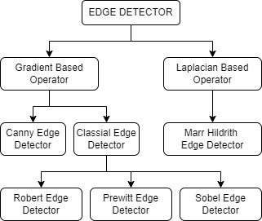

Abstract- Edge is a set of connected pixels which lie on the boundary between two regions which differ in grey value. The pixels on the edge are called the edge points. Edge detection plays a very important role in the analysis of different characteristics and properties of the image. When an edge is detected with the help of an Edge detection system, the unnecessary details are removed, while only the important structural information is retained. There are various Edge Detection Algorithms and Techniques available such as Robert, Prewitt, Sobel, Marr-Hildrith, Canny etc. which are used in the processing of images. This paper reviews all these gradient techniques and gives a brief analysis of all the Techniques. MATLAB is used as the software tool for the purpose of conversion of a RGB image to Grayscale and then produces a text file which contains all the pixel values of the image. The Xilinx ISE is used for the purpose of synthesis and configuring. Verilog HDL is used to design the whole system. The Hardware Description Language Code is implemented and synthesized on the Spartan 3E FPGA board.

Keywords: Edge Detection, FPGA, Verilog, MATLAB

Introduction
A digital image consists of a lot of Pixels with certain values of intensity. In a physical plane, an edge is the discontinuity in depth, change in materials, and light variations. In an image these are present as the gray scale discontinuities. An edge is defined as a set of connected pixels that lie on the boundary between the two regions of the image that differ in grey value [1][2][3]. The pixels on an edge are called as edge points. Various edge detection techniques and algorithms are available now-a-days which help to efficiently plot the edge present in an image [3]. Their classification can be done as follows as shown in Fig. 1(a) Gradient Based and Laplacian Operator based Techniques. Robert, Prewitt, Sobel and Canny are the Gradient Based Techniques whereas Marr Hildrith is Laplacian Based Operator Technique. The Classic gradient edge detector operators such as Prewitt, Robert, Sobel are simple to design and are very efficient in operation but they are prone to Noise [1][3]. The Noise effects in the image are occurred due to light variations, surface reflectance. Also, these classical operators have less accuracy due to high rate of error, missing of true edge and presence of thick edges in the image. In order to reduce the effects of noise the process of Image Smoothening is done and in order to improve the accuracy [4]. Canny Edge Detection Method is used, this method provides performance at par as compare to the classical edge detection algorithms [1][3]. The Canny Algorithm contains additional blocks such as Non-Maximal Suppression and Hysteresis Thresholding. Also, the canny algorithm becomes computationally more complex as

compare to the classical edge detection algorithms. This increases the latency and decrease the throughput.
Implementation design of different edge detection algorithms requires devices such as FPGA, GPPs and ASIC. As the image size and the computational complexity of the Edge Detection Algorithm increases, it becomes difficult to maintain the real time performance. GPPs are often used with digital signal processors to increase their performance on certain tasks. The GPPs and ASICs have specialized internal architecture that perform a limited set of tasks. However, there is no way to reprogram GPPs or ASIC, so they are not cost efficient in implementing an Edge Detection System [5]. FPGAs are useful when it comes to cost saving and reprogramming purposes. The high-level design control allows greater control over the performance characteristic of an FPGA and hence it becomes suitable for designing a low-power edge detector [5][6].
The rest of the paper is organized as follows: Section 2 of this paper gives a brief idea about various edge detection techniques, its classification and various classical gradient operators. Section 3 provides System Requirements for proposed approach. Section 4 discusses about the process of Simulation and Synthesis. Section 5 deals with the Implementation of the Edge detection System and the Section 6 gives the conclusion of the whole paper.

EDGE DETECTION

Edge Detection plays an important role in the analysis of an image. It helps us to distinguish between the various outlines of the object present in the image. Most edges present in the image are unique i.e., their orientation in space remains the same no matter from whichever point they are being viewed. An edge is typically extracted by computing the derivative of the image function. This contains edge, and the director of the derivative vector, which is the measure of orientation of the edge. Some of the edges which are normally encountered in the process are as shown in Fig. 2(a) Step Edge, Spike Edge, Ramp Edge and Roof Edge [1]. Whenever an Edge detection system is implemented on a Hardware a series of processes are followed in order to extract the desired characteristic from the Image. These are showing in Fig. 2(b) Filtering, Differentiation and Localization [2][3].

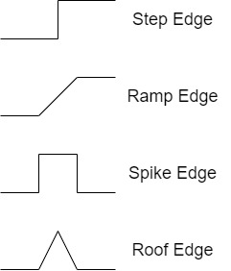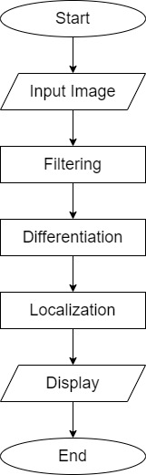
Fig. 2(a) Types of Edges Fig. 2(b) Edge Detection Process

Filtering refers to the process to filter the input image to get maximum performance for the edge detectors. It involves smoothing, where the noise can be suppressed without affecting the true edges of the image. In the differentiation phase distinguishment of one pixel from the other pixel is done. If the difference is non zero it implies that an edge exists at that point but if it is zero then there exist no edge point. The localization process involves determining the exact location of the edge. Also, in this stage the edge thinning and the edge linking steps are also performed to ensure the sharpness of the image is preserved [7].

2.1 TYPES OF EDGE DETECTION TECHNIQUES
There are various Edge Detection Techniques which are already discussed in brief in the Section 1. In this Section, the various edge detection techniques will be discussed in detail and how their efficiency and accuracy in detecting the edges of the image [3].
2.1.1. ROBERTS OPERATOR
The Roberts kernels are derivatives with respect to the diagonal elements [8]. Hence, they are also called as the cross-gradient operators. The Roberts operator is based on the cross-diagonal differences. The approximation of Roberts operator can be mathematically given as:
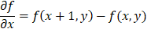
The approximation algorithm of Roberts Operator is given as
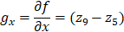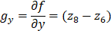

The Roberts masks for the give cross difference is:
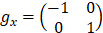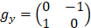

In the Robert edge detection method, the gradient of an image is through discrete differentiation, the gradient mask is of 2x2 matrix. The mask is convolved with the image using horizontal and vertical masks to give the edge detection in x and y direction respectively. For the 640x480 image, the Robert edge detection method uses 639x479x3 additions [9].

2.1.2 PREWITT OPERATOR
The Prewitt method takes the central difference between the neighbouring pixels [2]. This difference can be mathematically represented by

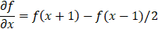

For two dimensions, this can be modified to:

This method is very much sensitive to noise and hence in order to avoid the effects of noise, the Prewitt method does some averaging using a 3x3 mask given below.

This approximation is called as the Prewitt operator and its mask is as follows:

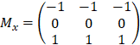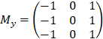

In the Prewitt edge detection method, the gradient of the mask is also through the discrete differentiation but the gradient mask is of 3x3 matrix. The mask is convolved with the image using horizontal and vertical masks to give the edge detection in x and y direction respectively. For the 640x480 image, the Prewitt method uses 638x478x11 additions [9].

2.1.3. SOBEL OPERATOR
The Sobel operator works on the central differences. This is equivalent to the first derivative of the Gaussian blurring image obtained by applying a 3x3 mask to the image [10].
The matrix approximation of the Sobel operator is given as:

The masks of the Sobel operator are given as:

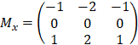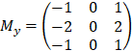

In order to detect edges in the diagonal direction, an additional mask is used:

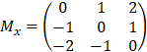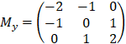

In the Sobel edge detection method, it is similar to Prewitt edge detection method but in Sobel operator there is ‘2’ and ‘-2’ in the centre of the first and third column of the horizontal mask and first and third row of the vertical mask. For the 640x480 image, the Sobel method uses 638x478x11 additions and 638x478x4 multiplications [9].

The Sobel Edge Detection Algorithm has a simple principle and good edge detection effect, also it is convenient to implement on a FPGA. Whenever we use a traditional Sobel Algorithm, we only get two templates of the image i.e., the Vertical Template and the Horizontal Template. The disadvantage of the traditional approach is that the edge detection in other directions is comparatively poor, so when a complex texture is detection, the detection has gaps and deficiency. So, a better approach is in which we implement an Eight Direction Sobel Edge Detection in order to reduce the loss of edge details. A 5x5 matrix is used to find out the convolution of the image in eight directions (0, 22.5, 45, 67.5, 90, 112.5, 135, 157.5) [11].

2.1.4. CANNY EDGE DETECTION

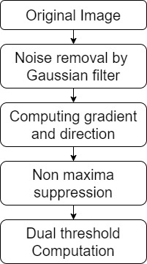
Canny Edge Detection is a multi-stage algorithm which detects a wide range of edges in an image [12][13]. This method is helps to quite precise edges present in the image but takes more time in processing as compared to the Classical Method of Edge Detection. It is useful when structural information is to be extracted from an image from different vision and different angles. There is a 5-step process in order to manually detect the edges present in the image as shown in Fig. 2.1.4 (a). Due to multiple stages in the detection process it has a very good performance as each step refines the image [14].

Fig. 2.1.4 (a)

2.1.5. MARR-HILDRITH OPERATOR
Marr-Hildreth algorithm is a method of detecting edges in a digital image in which continuous curves are present where there are strong and rapid variations in the brightness of the image [15]. The Marr-Hildrith operator is simple and works by convolving the image with the Laplacian of the Gaussian Function or as a fast approximation the difference of Gaussians can also be used. In Marr-Hildrith operator the Laplacian of the Gaussian (LoG) operator is performed. Fig. 2.1.5 (a) shows the block diagram of the operation of the Marr-Hildrith Operator.
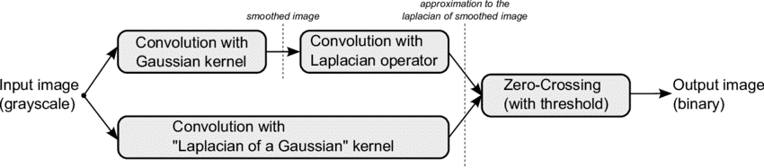Fig. 2.1.5 (a)

SYSTEM REQUIREMENTS
MATLAB provides a common working environment to Simulink and the Xilinx Integrated Design Suite. Fig. 3(a) below shows the System Generator for MATLAB configurator.
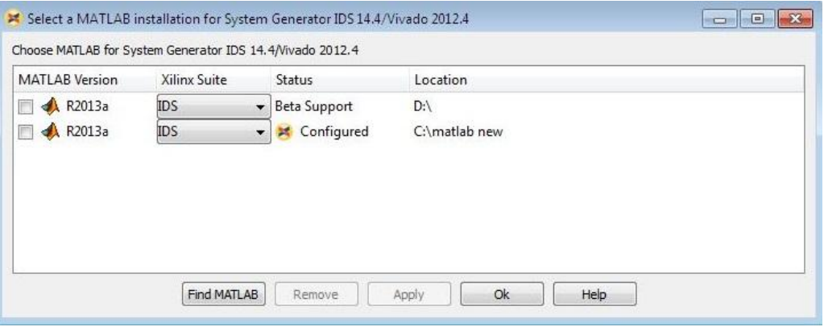Fig. 3(a)

Simulink is a software package for MATLAB which is used for the purpose of modelling, simulation and for the analysis of dynamical systems. It provides the user a graphical interface for building the models as block diagrams. It also includes a comprehensive block, library of sinks, sources and many non-linear components and connectors. The Simulink model is synthesized by using the Xilinx System Generator (XSG) block sets. The XSG then synthesizes the required design and the Hardware Description Code is generated [16].
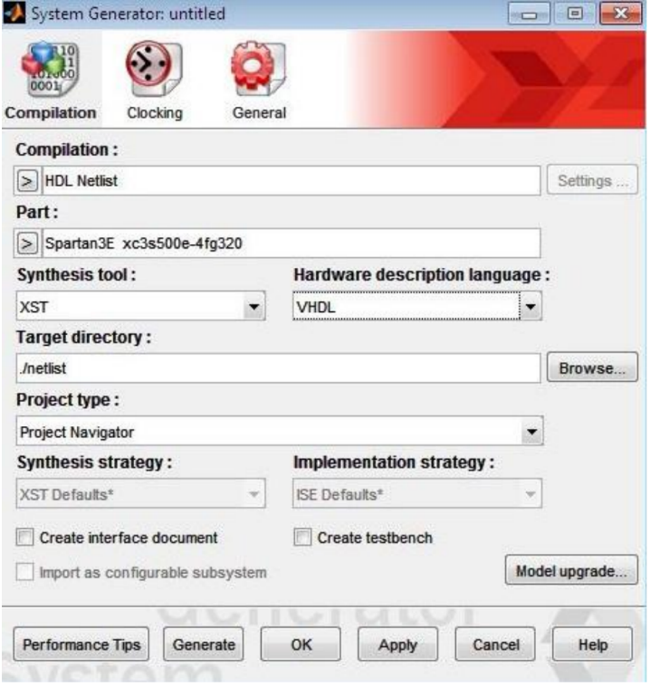
Fig. 3(b) - System Generator Window

This code can be further can be further simulated and synthesized in Xilinx Integrated Synthesis Design suit and further the design suit and the programming file generated can be implemented on the FPGA.

SIMULATION AND SYNTHESIS
There are various Proprietary and Open-Source Simulators available for the simulation of HDL codes. The Synthesis summary consists of information which is related to resources used in the implementation of the design. In Fig. 4(a), are all obtained using MATLAB functions of Edge Detection.
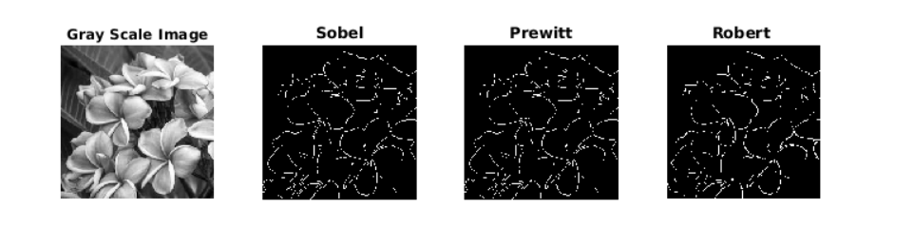
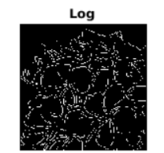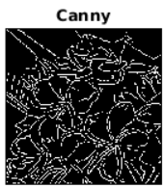

PROPOSED MODEL
In this paper, the implementation of Edge Detection Functions in MATLAB is discussed. The current technology is sufficient for implementation of Edge Detection using FPGA. It has very simple configuration. A 1080p/720p Camera can be used for can be used for capturing images. Now with the help of MATLAB to convert the pixels to a bitstream. Then this bitstream is passed to the FPGA, Xilinx Spartan 3E where certain Edge Detection Algorithms are preloaded inside the memory of the Spartan 3E board. These Algorithms detect the edge of the image and produce and output in the form of wave form and then these bits are again passed through a MATLAB program which convert it into a fully Edge Detected image. Fig. 4 shows the block diagram for implementing the Edge Detection Algorithm on an FPGA [18].
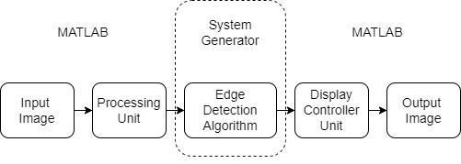Fig. 4

CONCLUSION
In this paper, a brief introduction of the various Edge Detection Techniques. The Gradient and Laplace Operator based techniques were discussed. The Gradient based classical operators have very low latency and high throughput and can be used in real time applications. The Gradient operators are used at places where the accuracy isn’t that important but the major focus is on the speed. But in cases where accuracy plays an important role, there we use the Canny Algorithms is used where accuracy is a major concerned. All, the observations shown in the paper are obtained with the help of MATLAB. Also, a model of a project is proposed in which the whole assembly of Edge Detection is implemented on a FPGA board.

REFERENCES
[1] | Sridhar, Digital Image Processing. Oxford, England: OUP, 2011.
[2] | R. C. Gonzalez and R. E. Woods, Digital Image Processing, Global Edition, 4th ed. London, England: Pearson Education, 2017.
[3] | E. Argyle and A. Rosenfeld, “Techniques for edge detection, ” Proc,” Proc. IEEE Inst. Electr. Electron. Eng, vol. 59, no. 2, pp. 285–287, 1971.
[4] | M. F. V. Ruslau, R. A. Pratama, Nurhayati, and S. Asmal, “Edge detection in noisy images with different edge types,” IOP Conf. Ser. Earth Environ. Sci., vol. 343, no. 1, p. 012198, 2019.
[5] | J. Schiel and A. Bainbridge-Smith, “Efficient edge detection on low-cost FPGAs,” arXiv [cs.AR], 2015.
[6] | D. R. Menaka, D. R. Janarthanan, and D. K. Deeba, “FPGA implementation of low power and high speed image edge detection algorithm,” Microprocess. Microsyst., vol. 75, no. 103053, p. 103053, 2020.
[7] | M. H. Ishak, N. N. Sofia Mohd Marzuki, M. F. Abdullah, Z. H. Che Soh, I. S. Isa, and S. N. Sulaiman, “Image quality assessment for image filtering algorithm: Qualitative and quantitative analyses,” in 2019 9th IEEE International Conference on Control System, Computing and Engineering (ICCSCE), 2019, pp. 162–167.
[8] | L. G. Roberts, Machine perception of 3D solids. Optical and electro-optical information processing. Cambridge: MIT Press, 1965.
[9] | G. N. Chaple, R. D. Daruwala, and M. S. Gofane, “Comparisions of Robert, Prewitt, Sobel operator based edge detection methods for real time uses on FPGA,” in 2015 International Conference on Technologies for Sustainable Development (ICTSD), 2015.
[10] | N. Kanopouls, N. Vasanthavada, and R. L. Baker, “Design of an image edge detection filter using the sobel operator,” IEEE J. Solid-State Circuits, vol. 23, no. 2, pp. 358–367, 1988.
[11] | Z. Xiangxi, Z. Yonghui, Z. Shuaiyan, and Z. Jian, “FPGA implementation of edge detection for Sobel operator in eight directions,” in 2018 IEEE Asia Pacific Conference on Circuits and Systems (APCCAS), 2018.
[12] | J. Canny, “A computational approach to edge detection,” IEEE Trans. Pattern Anal. Mach. Intell., vol. PAMI-8, no. 6, pp. 679–698, 1986.
[13] | D. Sangeetha and P. Deepa, “FPGA implementation of cost-effective robust Canny edge detection algorithm,” J. Real Time Image Process., vol. 16, no. 4, pp. 957–970, 2019.
[14] | R. M. Yousaf, H. A. Habib, H. Dawood, and S. Shafiq, “A comparative study of various edge detection methods,” in 2018 14th International Conference on Computational Intelligence and Security (CIS), 2018, pp. 96–99.
[15] | E. Dong, K. Li, and J. Tong, “FPGA based design and implementation of improved edge detection algorithm using LOG operator,” in 2018 IEEE International Conference on Mechatronics and Automation (ICMA), 2018.
[16] | A. G. Mahalle, “A review on FPGA implementation of edge detection algorithms,” Ijsr.net. [Online]. Available: https://www.ijsr.net/archive/v6i1/ART20164324.pdf. [Accessed: 14-Nov-2022].
[17] | A. Ravindran and Rajeswari, “FPGA implementation of approximate multiplier with edge detection application,” in 2022 6th International Conference on Intelligent Computing and Control Systems (ICICCS), 2022.
[18] | K. Zhang, Y. Zhang, P. Wang, Y. Tian, and J. Yang, “An improved Sobel edge algorithm and FPGA implementation,” Procedia Comput. Sci., vol. 131, pp. 243–248, 2018.

