Wireless and Sensors Network Security Threads and Count Measures Mazen A. Abdullahª, Maha A. Abdullah^{b}, Omar H. Alhazmiª
ª Computer Science department, Taibah University, Medina, KSA ; ^{b} Computer and Cyber Science department, University of Prince Mugrin, Medina, KSA.

Abstract
Wireless sensor network is domain-specific wireless system composed of various nodes called sensor nodes. The purpose of the nodes is to collect physical and environmental data parameters such as sound, pressure and temperature, and relay the data across the network through a central node. The goal is to get the data from the sensors in a secure manner. Data flow in wireless sensor networks is threatened by a variety of attack types, including Sybil, Wormhole, Sinkhole, and others. In order to accomplish privacy, integrity, availability, confidentiality number of protocols and techniques have been developed. In this paper we will provide a systematic review that spot the light on the common threats and the countermeasures proposed by the previous studies.

Keywords: WSN, security, threads

INTRODUCTION

The term "wireless sensor networks" (WSN) refers to that data collected from a variety of sensors placed in one place and monitoring the environment then safely sent to other sensors or network centers. WSN and sensors has various application in different fields such as health care, education, preserving the environment and Smart cities. WSN technology has also found usage in the industrial, commercial, computational, and other fields. The diversity of the dimensions imposes to keep the security level of these wireless networks. Moreover, while the wireless technology evolves the security threats has also evolve over time. Scientists have proposed number of security methods, but a common shortcoming in most of these models is that they are focused on a single weakness rather than being able to handle a wide range of WSN security threats.

The communication between the devices and sensors is wireless connection and it may divided in to several infrastructure figure 1 depict the infrastructure of IoT network.

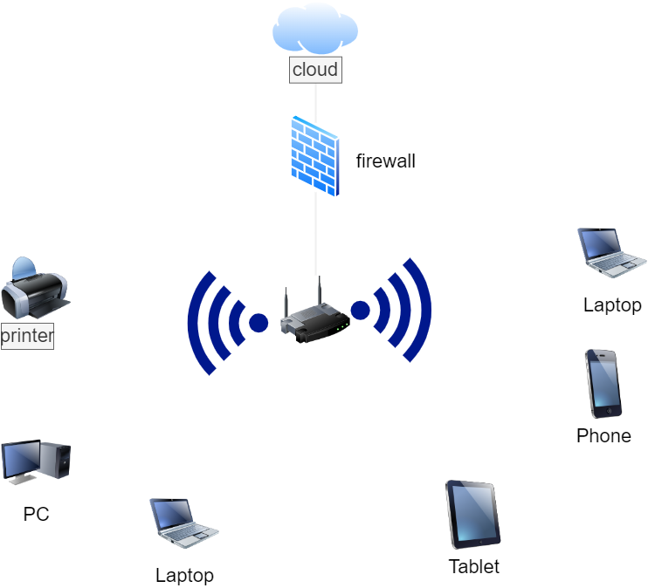
Figure 1: IoT infrastructure

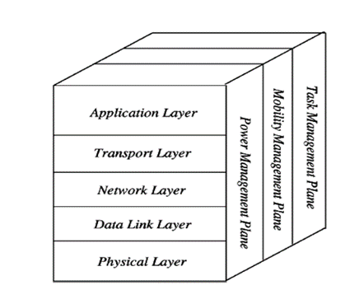
Figure 2: WSN layered structure

WSN is a layered structure, include five layers: application layer, transport layer, network layer, data link layer and physical layer, shown in figure 2. These layers are mainly used to accomplish the mobility and make the sensors work together in order to raise the efficiency of the network.

However, the layered structure of the wireless network could be one of reasons that make the WSN vulnerable [1]. The layered nature of WSN have allowed the attacker to target all the layers and search for any weak point that could be used. Additionally, the sensor network could be challenging in matter

of security too because of its limited nature, as it has a limited processing power, memory and battery.

In this paper we will conduct research on the wireless sensor network and compare between different security threads that faces this type of networks as well as the proposed counter measures for these threats.

Background

A. Wireless sensor network threads

According to [2] there are two categories of attacks in wireless sensor network passive and active attack. Passive attack where the intruder gets to the network and breach the confidentiality of the data without obstructing the network operation for example: eavesdrop or snooping. However, the active attack may damage the network in different ways such as breaches the data integrity like changing the data or availability such as Wormhole attack, blackhole attack and denial of service attack. The scholars have discussed multiple attacks and the countermeasure for each such as: Jamming, Denial of service, Collision, Hello packets attack, selective attack, and Sybil attack.

While in [3] the scholars have identified number of common threats in WSNs include spoofing, selective forwarding, sinkhole attack, Sybil attack, wormhole attack, hello flood attack, acknowledged spoof, denial of service attack, masquerade threat, replication of node, and rushing attack.

Moreover, different type of attacks can be implemented according to the layer of WSN structure targeted [4]. For instance (DoS) attack could be done in all the layers, while wormhole sinkhole and Sybil attack etc... usually targeting the network layer, and all types of malicious node attack performed in the application layer.

However, as the network layer is the most vulnerable layer in WSN structure [5]. Most of the attacker would target the routing protocol that controlling the traffic of the packets transporting to reach its destination efficiently [6].

• Network layer threats

We will discuss variety of network layer attacks in the following paragraph.

Denial of service attack (DoS): Since this kind of attack was carried out repeatedly across all WSN layers, any layer is vulnerable for DoS attack. A denial-of-service attack aims to take down a system or network, rendering the target audience unable to access it. DoS attacks function by saturating the target with traffic or by supplying information that makes the target fail.

Flooding Attack, the goal of this attack is to drain the network assets which may lead to a DoS attack. The nature of the WSN and its limited resources resulted in consuming the battery and affecting the bandwidth which decrease the overall performance of that network.

Blackhole Attack, when one of the nodes broadcasting that it has the shortest path to the destination node. So, whenever a node sends a request this malicious node will reply and create a fake path that either the packets dropped or used by the attacker to breach the confidentiality of the network.

Wormhole Attack, in this attack two malicious nodes create a tunnel to listen to all the packet even the one that is not intended to them.

Rushing Attack, the attackers create a wormhole using tunneling techniques. If a fast transmission path is available between the two ends of a wormhole, packets that tunneled via it can spread faster than any typical multi-hop route.

Link Spoofing Attack, with the exception of nearby nodes, a malicious node propagates false connections in this sort of attack to stop routing activities.

Replay Attack, as sensor nodes are mobile in WSN, the network topology is constantly changing, indicating that the current architecture won't last for a very long time. In such an attack, a detecting node records and subsequently retransmits the legitimate control messages of some other node, this is why, other nodes must maintain a record of their routing tables.

Sinkhole Attack: is a kind of selective forwarding attack. The attackers’ primary goal is to use a malicious node to draw attention to all of the traffic coming from a certain location to the malicious node that convince the other nodes it is a sink node then it drops all the packets.

Sybil attack, in this attack, the attacker obtains numerous identities on a node in an unauthorized manner. This attack specifically targets multi-path routing and other fault-tolerant systems.

Hello Flood Attack, the intruder delivers HELLO packets to numerous sensor nodes that are unreachable inside a wireless sensor network using high processing power and transmission range. These sensors assume that their neighbor is the intruder. Because they are aware of their neighbors, the damaged nodes attempt to transmit information through the intruder, but ultimately the intruder spoofs them.

• Application layer threads

Malicious Code Attack: to disassemble or take total control of a node, the attacker injects a worm into it. This might hinder the network's capacity to carry out its intended functions.

Attack on Reliability: it is occur when an intruder places malicious nodes between parties involved in communications to produce inaccurate data or requests, increase energy usage, and cause collisions.

B. Countermeasures

There were multiple countermeasures proposed in the reviewed papers, we will discuss the most common threats and the countermeasures for each. There are multiple defenses proposed in [3] such as multi-parent routing mechanism, cryptographic algorithm, key management protocol, location identification protocol, reputation-dependent protocol and anti-tamper mechanism.

While the countermeasures were presented according to the layers in [4]. For instance: strong authentication and identity procedures can stop most denial-of-service attacks. While validation techniques could prevent Sybil attacks.

However, the researchers in [5] believe that the right defense of these attacks by using suitable security protocols. Also, they have claimed that the network layer is the one which is the most vulnerable layer in network structure and to deal with these threats in this layer we may use secure routing, authentication, key management, encryption and all the techniques that could protect this layer. Sinkhole Attack, Sybil Attack Blackhole attack, Wormhole attack, HELLO Flood Attack, etc. are threats that use the vulnerability of network layer.

In [5] the scholars have used a simulator and emulator to represent the efficiency of these protocols on a virtual environment. After the simulation they come up with two threads that resolved using the security protocols: the Blackhole attack and Wormhole attack by MD5 authentication.

Although the previous methods were proposed to prevent the attackers from breaching the network but there is always a chance that they could find a way to overcome these methods. The scholar in [7] suggest that using the attack detection system in the network would be the best option as a backup plan. They have provided a brief deception for each layer and the detection algorithm used in each.

Furthermore, adding machine learning algorithms to the attack detecting technique and preventing could be a game changer. According to [8] the Machine Learning (ML) algorithm can be investigated with WSN to secure the nodes and prevent any possible attack. Nevertheless, these algorithms may not be suitable for the limited processing power of WSN nodes. They claimed that using Software Defined Network (SDN) technology is one of the most important and effective options for extending the use of ML algorithms in other security areas. It may be utilized to decrease the cost of consumption and increase WSN node efficiency.

discussion
in this section we will present an overview on the common threats and the proposed solution by the previous studies.

Table 1. previous studies summarization
Attack | WSN Layer affected | Detecting and preventing technique | Ref.
Wormhole attack | Network | - MD5 authentication  -Administrator-Viewpoint models, | [5]  [9]
Sinkhole attack | Network | a Probe Route based Defense Sinkhole Attack (PRDSA) | [10]
Denial of service attack | All the layers | - authentication and identity strict methods  - Media Access  Control (MAC) protocols | [4][7]
Selective forwarding attack | Network | Redundancy Technique,  Probing Mechanisms | [1]
Jamming | Physical | -proportional-integral-derivative (PID) control  -Swarm Intelligence, | [11]
Sybil attack | Network | Validation techniques | [4]
flooding attack | Network | -LEACH and PEGASIS protocols  -dynamic time-based forwarding window technique | [4][12]
Unfairness | Data link | Usage of small frames | [13]
HELLO flooding attack | Network | 2-Way Authentication  Mechanisms | [1]
Acknowledgement spoofed | Data link | Error Correction Code | [1]

From table 1 we can see that most of the attacks is targeting network layer. However, there was different solutions proposed based on the attack type for example, in [5]and [9] the scholars claim that to overcome this type of attacks a secure routing must be maintained, and the usage of many protocols is required. They also claimed that the best protocol to handle the wormhole attack is “MD5 public key encryption” protocol. MD5, insure a secure routing by discovering single-hop or two-hop neighbor and then use the ID of them to establish a secure connection.
However, there’s some attacks that target all layers and it may consider hard to be detected and defeated, Denial of services attack is one of them. As it may look simply but its results may cause catastrophe harms for example if it targeted a bank or any economic system it would cause a huge lose. One of the ways that suggested b y [7] was intrusion detection methods. Adding a detecting tool in each layer would maintain the required level of security.

conclusion
As the WSN technology is relatively new, the current sensors in the market have low memory, limited battery capabilities and low processing power. The implication is that the security capabilities that were applicable to wired sensors are ineffective in sensor nodes, and hence they are vulnerable to new security threats. Due to the limited nature of WSN, it might be a challenging to secure the network without affecting the performance. Other challenges to WSNs security include use of wireless media access, limited sensor resources, limitations of physical safeguards, diverse network topologies, and the immense scale of the WSNs. There are diverse attacks and attack classification, the attacks could be classified as passive and active attacks, based on the security goal breached in the attack. additionally, the attacks could be classified according to the layer affected by the attack. To sum up, we provide a review on variety of attacks that threaten the WSN, the layer affected and proposed solutions by number of literature work.

References
- A. Karakaya and S. Akleylek, "A survey on security threats and authentication approaches in wireless sensor networks," 2018 6th International Symposium on Digital Forensic and Security (ISDFS), 2018, pp. 1-4, doi: 10.1109/ISDFS.2018.8355381.

- SunilKumar, K. N. (2017, May). A review on security and privacy issues in wireless sensor networks. In 2017 2nd IEEE International Conference on Recent Trends in Electronics, Information & Communication Technology (RTEICT) (pp. 1979-1984). IEEE.‏

- U. Inayat, F. Ali, H. M. A. Khan, S. M. Ali, K. Ilyas and H. Habib, "Wireless Sensor Networks: Security, Threats, and Solutions," 2021 International Conference on Innovative Computing (ICIC), 2021, pp. 1-6, doi: 10.1109/ICIC53490.2021.9693021.

- Pandey, A., & Tripathi, R. C. (2010). A survey on wireless sensor networks security. International Journal of Computer Applications, 3(2), 43-49.‏

- Tech, M., & EED, V. Security and Authentication Protocol and Security Threats in WSN.

- Riaz, M. N., Buriro, A., & Mahboob, A. (2018). Classification of attacks on wireless sensor networks: A survey. International Journal of Wireless and Microwave Technologies, 8(6), 15-39.

- ‏Xie, H., Yan, Z., Yao, Z., & Atiquzzaman, M. (2018). Data collection for security measurement in wireless sensor networks: A survey. IEEE Internet of Things Journal, 6(2), 2205-2224.

- Ahmad, R., Wazirali, R., & Abu-Ain, T. (2022). Machine learning for wireless sensor networks security: an overview of challenges and issues. Sensors, 22(13), 4730.

- Mohammed, D., Omar, M., & Nguyen, V. (2018). Wireless sensor network security: approaches to detecting and avoiding wormhole attacks. Journal of Research in Business, Economics and Management, 10(2), 1860-1864.

- Liu, Y., Ma, M., Liu, X., Xiong, N. N., Liu, A., & Zhu, Y. (2018). Design and analysis of probing route to defense sink-hole attacks for Internet of Things security. IEEE Transactions on Network Science and Engineering, 7(1), 356-372.‏

- Wang, F., Zhong, C., Gursoy, M. C., & Velipasalar, S. (2020, March). Defense strategies against adversarial jamming attacks via deep reinforcement learning. In 2020 54th annual conference on information sciences and systems (CISS) (pp. 1-6). IEEE.‏

- K. Venkatraman, J. V. Daniel, and G. Murugaboopathi, “Various Attacks in Wireless Sensor Network: Survey,” International Journal of Soft Computing and Engi

- Riaz, M. N., Buriro, A., & Mahboob, A. (2018). Classification of attacks on wireless sensor networks: A survey. International Journal of Wireless and Microwave Technologies, 8(6), 15-39.‏

- Sen, B., Meitei, M. G., Sharma, K., Ghose, M. K., & Sinha, S. (2018). A trust-based intrusion detection system for mitigating blackhole attacks in MANET. In Advanced Computational and Communication Paradigms (pp. 765-775). Springer, Singapore.‏

- Radhappa, H., Pan, L., Xi Zheng, J., & Wen, S. (2018). Practical overview of security issues in wireless sensor network applications. International journal of computers and applications, 40(4), 202-213.‏

- Pundir, S., Wazid, M., Singh, D. P., Das, A. K., Rodrigues, J. J., & Park, Y. (2019). Intrusion detection protocols in wireless sensor networks integrated to Internet of Things deployment: Survey and future challenges. IEEE Access, 8, 3343-3363.‏

- Mamdouh, M., Elrukhsi, M. A., & Khattab, A. (2018, August). Securing the internet of things and wireless sensor networks via machine learning: A survey. In 2018 International Conference on Computer and Applications (ICCA) (pp. 215-218). IEEE.‏

- Ghani, A., Mansoor, K., Mehmood, S., Chaudhry, S. A., Rahman, A. U., & Najmus Saqib, M. (2019). Security and key management in IoT‐based wireless sensor networks: An authentication protocol using symmetric key. International Journal of Communication Systems, 32(16), e4139.‏

- Alghamdi, T. A. (2018). Secure and energy efficient path optimization technique in wireless sensor networks using DH method. IEEE Access, 6, 53576-53582.‏

- Cao, B., Zhao, J., Gu, Y., Fan, S., & Yang, P. (2019). Security-aware industrial wireless sensor network deployment optimization. IEEE transactions on industrial informatics, 16(8), 5309-5316.‏ ‏‏‏
- Gedeon, J., Heuschkel, J., Wang, L., & Mühlhäuser, M. (2018). Fog computing: Current research and future challenges. KuVS-Fachgespräch Fog Comput, 1, 1-4.‏ on industrial informatics, 16(8), 5309-5316.‏

